Face detection :-

These are various algorithms for face detection, but some of the most common ones are:

1. Viola-Jones Algorithm:

The Voila-Jones Algorithm is one of the most Popular face detection algorithms. It is based on the concept of Haar features, which are patterns that are repeated in different parts of the face. The algorithm first identifies the region of the image that might contain a face and then uses a set of classifiers to detect the presence of a face in the region.

1. Constitutional Neural Networks (CNNs):-

CNNs are deep learning algorithms that can be trained to detect faces. These algorithms are trained on a large dataset of images, and they learn to identify the features that are common to faces. Once trained, a CNN can be used to detect faces in new images.

1. Histogram of Oriented Gradients (HOG):-

The HOG algorithm works by calculating the gradient of the image and then grouping the gradients into cells. The gradients are then normalized, and a histogram is created based on the direction of the gradients. This histogram is then used to detect the presence of a face in the image.

Here is an example of how the HOG algorithm might work for face detection:-

* 1. The input image is preprocessed to normalize illumination and contrast.
  2. The gradient of the image is calculated by computing the horizontal and vertical derivations.
  3. The image is divided into small, overlapping blocks, and the gradient orientation in each block is calculated.
  4. The histograms of gradient orientations in each block are normalized to account for variations in lighting and contrast.
  5. The normalized histograms of gradient orientations in each block are concatenated into a feature vector for the entire image.
  6. The feature vector is used to train a binary classifier, such as a Support vector machine(SVM), which can distinguish between face and non-face images.
  7. The trained classifier is applied to sliding windows of the input image to detect potential face regions.
  8. Non-maximum suppression is applied to remove redundant detection and retain the highest scoring window.

1. Skin Color Segmentation:-

This algorithm works by segmenting the skin regions of an image using color information. The algorithm first identifies the skin color in the image and then segments the skin regions. This methods is less accurate than other algorithms, but it is faster and less computationally intensive

 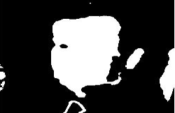

Input Image skin detection using threshold value

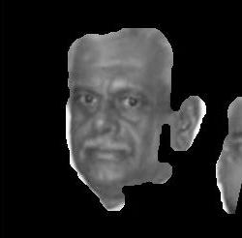 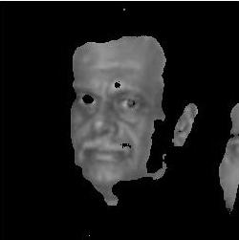

Morphological filled image Face detection

Here are the steps involved in a typical skin color segmentation algorithm for face detection:-

* 1. The original image is first converted to the RGB color space and the red, green, and clue channels are extracted.
  2. A threshold is applied to each color channels to identify skin color regions.
  3. The threshold images for each color channel are merges to create binary mask.
  4. Morphological operations are performed on the binary mask to remove noise and fill gaps in the skin color regions.
  5. The skin color regions are analyzed to identify regions are analyzed to identify regions that are likely to contain faces.

1. Template Matching:-

This algorithm works by comparing a template image of a face with regions of the input image. The algorithm searches for regions in the image that closely match the template, and then determine the presence of a face based on the similarity of the matched regions.the algorithm may be accurate in some cases, but it can be prone to false positives and may not work well with variations in lighting, pose, and facial expression.

In the context of face detection, a template image of a face is first created by selecting a typical frontal view of a face and cropping it to a standard size.The template matching Algorithm then works by sliding the template image over the image being analyzed and comparing the template with each sub-region of the image .this is done by calculating the correlation coefficient between the template and the sub-region of the image. The correlation coefficient is a measure of how similar the two images are, with a value of 1 indicating a perfect match.

The algorithm searches for regions in the image that have a high correlation coefficient with the template image, and then identifies these regions as potential faces. Once potential face regions are identified, further analysis is done to filter out false positives and refine the detection of actual faces.